Kingdom of Saudi Arabia  Ministry of Education  Najran University  College of Computer Science  and Information Systems |  |  | المملكة العربية السعودية  وزارة الـتـعـلـيـــــــــــم  جـامـعــــــة نــجـــــران  كلية علوم الحاسب ونظم المعلومات
[Choose your department]
[Choose the course] ([course code])
[Project title in title case: capitalise the first and all major words; keep a, an, the, and, or, of, in, on, for, to lower-case unless first]
A project report submitted in partial fulfillment
of the requirements for the degree of
[Choose the degree]
By
Student Name |  | University ID
[Full name as registered in the university academic system] |  | [University ID]
[Full name as registered in the university academic system] |  | [University ID]
[Full name as registered in the university academic system] |  | [University ID]
[Full name as registered in the university academic system] |  | [University ID]
[Delete unused rows; copy a row for each further member.]
Supervisor: [Title and full name]
Co-supervisor: [Title and full name — delete this line if there is no co-supervisor]
Examination Panel
[Title and full name], Chair
[Title and full name]
[Title and full name — delete this line if not needed]
[Choose the semester], Academic Year [14xx AH (20xx–20xx)]

Declaration
We, the undersigned members of the project team, declare that this report, entitled “[Project title — from the cover]”, submitted for [Course — from the cover] in the Department of [Department — from the cover], College of Computer Science and Information Systems, Najran University, is our own original work. All the analysis, design and development reported here were carried out by the team, every source used is acknowledged and cited, and this work has not been submitted to any other college or university.
Member name | University ID | Signature | Date
[Full name] | [University ID] |  | [Date]
[Full name] | [University ID] |  | [Date]
[Full name] | [University ID] |  | [Date]
[Full name, or delete this row] | [University ID] |  | [Date]

Abstract
[150–300 words, one paragraph, no citations: the problem, the objective, the approach, the main result or prototype outcome, and its significance.]
[Abstract: one paragraph of 150–300 words]
Keywords: [3–6 keywords]

الملخص
[Optional unless your department requires it: Arabic translation of the abstract, 150–300 words. Delete this page if not used.]
[الترجمة العربية للملخص]

Acknowledgments
[Optional. Thank the supervisor, co-supervisor, industrial partner, participants or others. Delete this page if not used.]
[Acknowledgments text]
Table of Contents
[Right-click here and choose Update Field → Update entire table after completing the report]

List of Figures
[Right-click here and choose Update Field after inserting figure captions]

List of Tables
[Right-click here and choose Update Field after inserting table captions]

List of Abbreviations
[Delete this page if fewer than five abbreviations are used.]
Abbreviation | Meaning
[ABC] | [meaning]
[ABC] | [meaning]
[ABC] | [meaning]

Introduction
[GP1 and GP2. Introduce the project and outline the chapter.]

Context and Motivation
[GP1 and GP2. Describe the domain and the setting and explain why the problem matters; support it with cited evidence.]
Sample text: Table 1.1 summarises the sample data and Figure 1.1 shows the sample diagram; refer to every table and figure in the text in this way (References > Cross-reference).
[Sample table and figure: insert captions with References > Insert Caption (table captions above the table, figure captions below) and cross-references with References > Cross-reference; delete this sample.]
Table 1.1: [Caption in sentence case]
[Column heading] | [Column heading] | [Column heading]
[Value] | [Value] | [Value]
[Value] | [Value] | [Value]
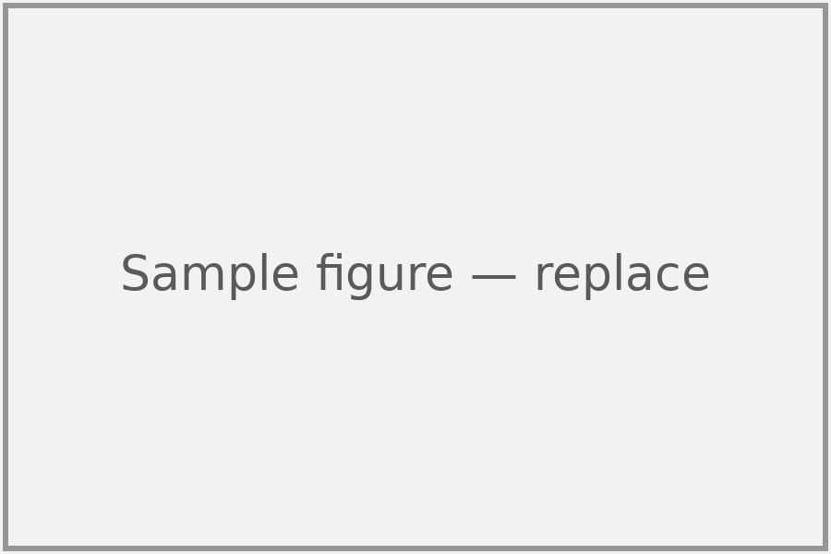
Figure 1.1: [Caption in sentence case]

Problem Statement
[GP1 and GP2. State the problem precisely: who is affected, what is wrong today, and the evidence for it.]

Aim and Objectives
[GP1 and GP2. State one aim, then measurable, numbered objectives O1, O2, … that can be verified at the end of GP2; Chapter 8 reports their achievement.]

Scope, Assumptions and Limitations
[GP1 and GP2. State what is in and out of scope, the assumptions made and the known limitations. In GP2, explain any change since GP1 in Section 5.6.]

Stakeholders and Target Users
[GP1 and GP2. Identify the stakeholders, the target users and, if any, the external partner.]

Report Organisation
[GP1 and GP2. Summarise the content of each following chapter in one sentence.]

Background and Related Work
[Written in GP1; updated in GP2. Review the background and the existing solutions and show the gap this project fills.]

Background Concepts
[Explain only the concepts, technologies and standards the reader needs to follow the report.]

Existing Solutions and Literature
[Review the existing systems, products and published work that address the same or a similar problem; cite every source in the References.]

Critical Comparison
[Compare the existing solutions in a table (solution, approach, features, limitations, relevance) with a caption from References > Insert Caption, and discuss their strengths and weaknesses rather than only listing them.]
Solution | Approach | Features | Limitations | Relevance to this project
[Solution 1] | [Approach] | [Features] | [Limitations] | [Relevance]
[Solution 2] | [Approach] | [Features] | [Limitations] | [Relevance]
[Solution 3] | [Approach] | [Features] | [Limitations] | [Relevance]

Gap Addressed
[State the gap left by the existing solutions and how this project addresses it.]

Methodology and Project Management
[Written in GP1; updated in GP2. Explain how the project is carried out: the method, the plan, the roles, the risks and the resources.]

Development Methodology and Tools
[Name the development methodology (for example Scrum, iterative or waterfall) and justify it; list the tools, languages and platforms.]

Work Plan and Milestones
[Give the plan for both semesters with its milestones and a Gantt chart.]

Roles and Task Allocation
[State each member’s role and main tasks.]

Risk Analysis and Mitigation
[List the main risks with their likelihood, impact and mitigation.]

Resources and Partner Arrangements
[List the hardware, software, data and budget needed and who provides them. If the project has an external partner, describe what the partner provides; otherwise write “Not applicable”.]

Ethical and Legal Considerations
[Describe the ethical, legal and social issues the project raises, for example work with people, personal data or licensed software and data, and how the team dealt with them; otherwise write “Not applicable”.]

Requirements Specification
[Written in GP1; updated in GP2. State complete, consistent and testable requirements.]

Elicitation Method
[Describe how the requirements were gathered (interviews, questionnaires, document analysis, observation) and from whom; if the team collected data from people, Section 3.6 describes how it was handled.]

User Classes
[Describe each class of user, its characteristics and its permissions.]

Functional Requirements
[Number each requirement FR-1, FR-2, … and write one testable statement per requirement, with its priority and source.]
ID | Statement | Priority | Source
FR-1 | [The system shall …] | [Must / Should / Could] | [Source]
FR-2 | [The system shall …] | [Must / Should / Could] | [Source]
FR-3 | [The system shall …] | [Must / Should / Could] | [Source]

Non-functional Requirements
[Number each requirement NFR-1, NFR-2, … and make each one measurable (for example response time, availability or security level).]
ID | Statement | Priority | Source
NFR-1 | [Measurable statement] | [Must / Should / Could] | [Source]
NFR-2 | [Measurable statement] | [Must / Should / Could] | [Source]
NFR-3 | [Measurable statement] | [Must / Should / Could] | [Source]

Constraints
[List the technical, legal, time and resource constraints.]

Use-Case Model or Discipline Equivalent
[Give the use-case diagram and the main use-case descriptions, or the equivalent model of your discipline.]

System Analysis and Design
[Written in GP1; in GP2 present the final design and add Section 5.6. Use the models of your discipline: UML/ERD for software; BPMN and data models for information systems; topology, addressing, protocol and simulation models for network projects.]

Analysis Models
[Present and explain the analysis models, for example class, activity, sequence or data flow diagrams.]

System Architecture
[Show the overall architecture (components, layers, interfaces, deployment nodes) in a figure and explain it.]

Data Design
[Present the data model, database schema or data formats and the data flows.]

Interface Design
[Present the user interfaces (wireframes or screenshots) and the external interfaces or APIs.]

Design Decisions and Rationale
[For each major decision give the alternatives considered and the reason for the choice.]

Changes since GP1 [GP2]
[GP2 only; GP1 teams delete this section. Summarise the changes to the scope, objectives and design made since the GP1 report, and the reasons for them.]

Implementation
[Describe how the system was built.]

Technology Stack
[List the languages, frameworks, platforms and services used and justify each choice.]

Implementation by Component
[Describe the implementation of each component or module, with references to the source code.]

Key Algorithms and Technical Decisions
[Explain the key algorithms, protocols or configurations and the main technical decisions, with their reasons.]

Deployment
[Describe how the system is built, configured and deployed (environment, steps, configuration).]

Third-Party Components, Data Sets and Pre-trained Models
[List the libraries, code, data sets and pre-trained models that the team did not create, with their licences, and cite each in the References.]
Component | Version | Source (URL) | Licence | Where and how it is used | Modifications made
[Component 1] | [Version] | [URL] | [Licence] | [Where and how used] | [Modifications]
[Component 2] | [Version] | [URL] | [Licence] | [Where and how used] | [Modifications]
[Component 3] | [Version] | [URL] | [Licence] | [Where and how used] | [Modifications]

Testing and Evaluation
[Summarise the testing and the evaluation here and put the full test tables in Appendix A.]

Test Strategy and Environment
[Describe the test levels (unit, integration, system, acceptance), the tools and the test environment.]

Test Cases and Results
[Summarise the test cases and their results (passed, failed, defects found and fixed); put the full set in Appendix A.]

Requirements-to-Test Traceability
[Show which tests verify each FR and NFR (traceability matrix).]

Performance Measurements and User Evaluation
[Report the performance measurements and, if any, the user evaluation; if it involved people, Section 3.6 describes how it was handled.]

Analysis of Results
[Analyse the results against the objectives and the requirements; discuss failures and threats to validity.]

Conclusion and Future Work
[Summarise the outcome of the project and look ahead.]

Achievement of Objectives
[For each objective of Section 1.3 give the evidence and its status in the table below.]
Objective | Evidence (section, test or measurement) | Status
[O1 — objective] | [Section, test or measurement] | [Status]
[O2 — objective] | [Section, test or measurement] | [Status]
[O3 — objective] | [Section, test or measurement] | [Status]

Limitations
[State the limitations of the work and of its evaluation.]

Future Work
[Propose concrete future work.]

Lessons Learned
[State the main technical and team-work lessons learned.]

References
[Cite in the text as [1], [2] in order of first citation and list every source here in IEEE style. Software, data sets and pre-trained models are cited with version and URL. Use References > Insert Citation (style IEEE) or Zotero/Mendeley, or type entries in the Reference List style. The three entries below are worked examples (journal article, conference paper, software); replace them with your own sources.]
- Y. LeCun, Y. Bengio, and G. Hinton, “Deep learning,” Nature, vol. 521, no. 7553, pp. 436–444, May 2015, doi: 10.1038/nature14539.
- K. He, X. Zhang, S. Ren, and J. Sun, “Deep residual learning for image recognition,” in Proc. IEEE Conf. Comput. Vis. Pattern Recognit. (CVPR), Las Vegas, NV, USA, 2016, pp. 770–778, doi: 10.1109/CVPR.2016.90.
- PyTorch Foundation, PyTorch (version 2.4.0) [Computer software]. 2024. [Online]. Available: https://pytorch.org
- [Reference]
- Supplementary Material
[Extra diagrams, full test tables, questionnaires, screenshots. Delete if unused.]

How to Use This Template — delete this page before submission
- Template v1.0 (2026-10-14) — issued by the Graduation Projects Unit, College of Computer Science and Information Systems, Najran University. Use the latest version from the Graduation Projects Unit page on the college website.
- Edit in Microsoft Word (desktop, Windows or Mac) or Word for the web. Google Docs and LibreOffice are not supported for the final file.
- Choose the department, course and degree and type the project title once on the cover; the Declaration repeats the title, course and department automatically. Type the course code exactly as it appears in your schedule in the university’s academic system; the current codes are: Computer Science 571CSS-2 (GP1) and 572CSS-3 (GP2); Information Systems 571CIS-2 (GP1) and 572CIS-3 (GP2); Network and Communications Engineering 461CCN-3 (GP1) and 462CCN-3 (GP2).
- Fill every grey placeholder; delete every blue italic guidance paragraph. Before submission, search the document for the Template Instruction style and for “[” to find anything left; citation numbers such as [1] stay.
- Agree with your supervisor which chapters and sections your report needs and delete the others; Section 5.6 is for GP2 only. In GP2, update the chapters written in GP1. Word renumbers the headings automatically.
- Each member signs the Declaration in the Signature column and fills in the date.
- Styles: Body Text for paragraphs; Heading 1–3; List Bullet / List Number; Caption through References > Insert Caption (table captions above the table, figure captions below); Reference List (IEEE). Do not change fonts, margins or page size.
- Before exporting: Ctrl+A, F9, choose “Update entire table” for the Table of Contents, List of Figures and List of Tables.

